

America’s

Founders

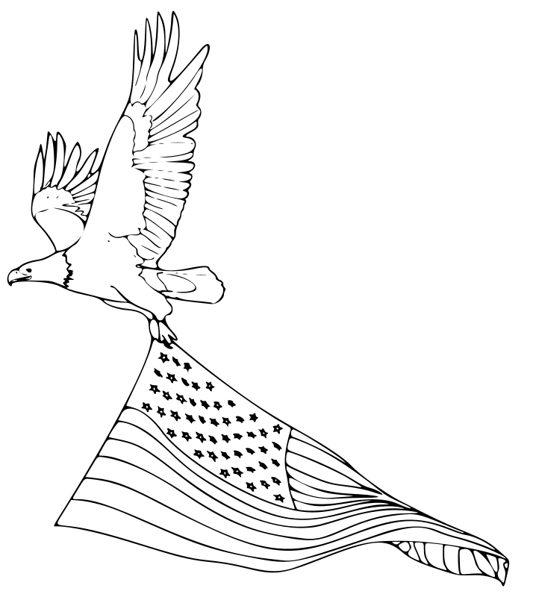

Open Clipart

Provided By American History Live and Florida Explorers Association

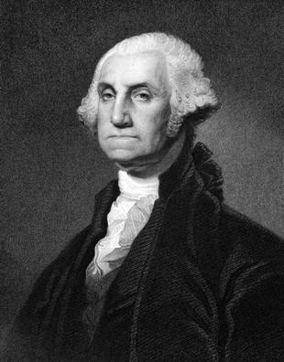

Library of Congress

George Washington

Birthdate: ________________________________

Home State: ______________________________

Role in the American Revolution:

______________________________________________

Role in the Constitutional Convention:

______________________________________________

Role in American Government:

______________________________________________

President Washington established the precedent of

Presidents serving _______________ terms in office.

One interesting fact about George Washington:

_____________________________________________

George Washington’s Greatest Contribution to America:

______________________________________________

______________________________________________

______________________________________________

______________________________________________

______________________________________________

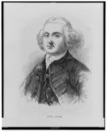

Library of Congress

John Adams

Birthdate: ________________________________

Home State: ______________________________

Role in the Second Continental Congress:

______________________________________________

Role in the American Revolution:

______________________________________________

First Role in American Government:

______________________________________________

Second Role in American Government:

______________________________________________

One interesting fact about John Adams:

_____________________________________________

John Adams was the first president to live in the White House. Draw a picture of the White House:

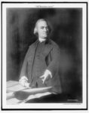

Library of Congress

Samuel Adams

Birthdate: ________________________________

Home State: ______________________________

Founded: ________________________________

His organization led the raid of British ships at Boston Harbor; this was called the:

___________________________________________

Signed Document to Great Britain establishing American independence:

______________________________________________

Helped create America’s first government under the:

______________________________________________

One interesting fact about Samuel Adams:

_____________________________________________

Draw a picture of the Sons of Liberty Flag:

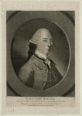

Library of Congress

John Hancock

Birthdate: ________________________________

Home State: ______________________________

President of: ________________________________

Largest Signature on the:

___________________________________________

Put Your John Hancock below:

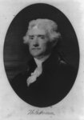

Library of Congress

Thomas Jefferson

Birthdate: ________________________________

Home State: ______________________________

Primary Writer of the:

________________________________

The Declaration of Independence establishes that

government should be for the ________________ and by

the ______________

Another founding principle is that all men are created

___________________

Thomas Jefferson was America’s first:

______________________________________________

Thomas Jefferson was America’s second:

_____________________________________________

Thomas Jefferson was America’s third:

_____________________________________________

This doubled the size of America:

____________________________________________

What is Jefferson’s greatest accomplishment?

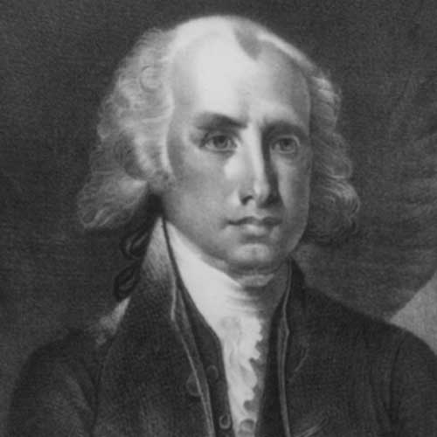

Library of Congress

James Madison

Birthdate: ________________________________

Home State: ______________________________

Helped Write the Virginia __________________________

and the Virginia Declaration of ______________________

James Madison is the Father of the __________________

Madison’s plan for the new government included

___________________ branches of government.

To convince Americans to adopt the United States

Constitution, James Madison wrote 29

______________________________________________

James Madison was America’s fourth:

_____________________________________________

The most significant event during James Madisons presidency was:

_____________________________________________

The United States Constitution creates a government that has checks and balances. Why is this important?

______________________________________________

______________________________________________

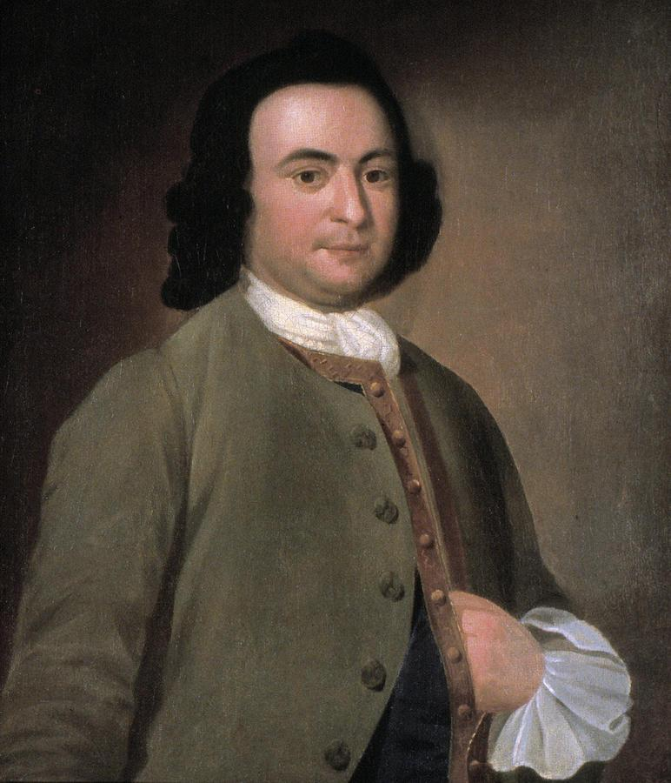

PICYRL

George Mason

Birthdate: ________________________________

Home State: ______________________________

Helped Write the Virginia __________________________

and the Virginia Declaration of ______________________

George Mason refused to sign the __________________

because it lacked a Bill of ____________________

Those opposed to the Constitution were called _________

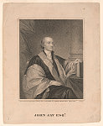

Library of Congress

John Jay

Birthdate: ________________________________

Home State: ______________________________

John Jay served in the ___________________________

trying to prevent seperation from England, but eventually

supported American Independence and served in the

_________________________________ during the war.

John Jay was the first ____________________________

Discover another American patriot on your own:

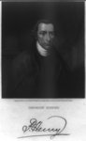

Library of Congress

Patrick Henry

Birthdate: ________________________________

Home State: ______________________________

Patrick Henry’s most famous quote:

“Give me _____________, or give me _____________.”

Patrick Henry opposed the ratification of the United States

Constitution because it lacked a Bill of _______________.