**Who Was Alexander Hamilton? Activities**

**Interactive Trivia**

1. Where was I born?
   1. Nevis c. Philadelphia, Pennsylvania
   2. New York, New York d. Paris, France
2. I was able to go to college because my community helped. What prompted that help?
   1. My work at a mercantile house
   2. My good grades.
   3. A letter I wrote about a hurricane in the newspaper
   4. My passion for American independence.
3. I left college early because
   1. I ran out of money.
   2. My parents needed me at home.
   3. I was kicked out for my revolutionary ideas.
   4. The American War for Independence broke out.
4. I was an aide to the commander of the American Army. Who was the commander?
   1. Benjamin Franklin c. George Washington
   2. Thomas Jefferson d. John Adams
5. After the war, I became a
   1. Lawyer. C. politician
   2. Banker. D. patriot
6. I represented this state at the Constitutional Convention
   1. Pennsylvania c. Massachusetts
   2. Georgia d. New York

1. In order to convince Americans to ratify the Constitution, I wrote
   1. Declaration of Independence
   2. Federalist Papers
   3. Bill of Rights
   4. I did not support the ratification of the Constitution
2. My role in the government was
   1. President c. Secretary of State
   2. Vice President d. Secretary of Treasury
3. As Secretary of the Treasury, I
   1. Coined money c. created the Coast Guard
   2. Collected taxes d. All of the above

**Alexander Hamilton Poster**

Alexander Hamilton was a patriot, soldier, founding father, and government official. Create a poster title: Alexander Hamilton: Symbol of America. Elements can include his work to create our American government, his military service, and his work as Secretary of the Treasury.

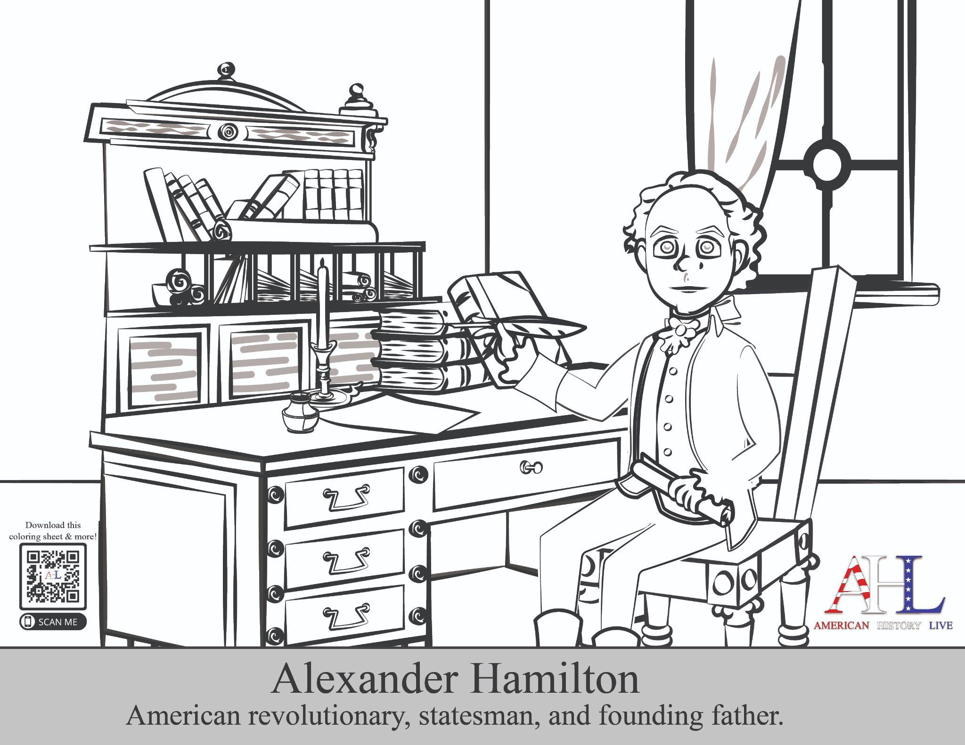

**Alexander Hamilton Traditional Assessment**

**Places for Alexander Hamilton**

|  |  |  |
| --- | --- | --- |
| New York | Nevis | Yorktown |

1. Born ____________________
2. Went to College _______________
3. Final Battle of the War _____________

**Alexander Hamilton: Founding Father**

|  |  |  |
| --- | --- | --- |
| Treasury | Constitution | Federalist Papers |
| Coast Guard | Lawyer | Continental Army |
| James Madison | George Washington | Aaron Burr |

1. After seeing how England was treating the American colonies,

Alexander Hamilton joined the ________________________

1. In the Army, Alexander Hamilton served as an aide to

________________________________

1. After the war was over, Mr. Hamilton became a _________________
2. This document created America’s national government.

_________________________________

1. Along with _________________________, Mr. Hamilton wrote

__________________________.

1. Mr. Hamilton was the first Secretary of ________________________
2. Secretary Hamilton helped create the _______________________
3. Mr. Hamilton dueled __________________________

**Short Answer**

1. Alexander Hamilton helped create America the nation. What do you think is his greatest contribution, and why?

**The United States Coast Guard**

In 1790, Alexander Hamilton established the Revenue Cutter Service, which became the United States Coast Guard. The Coast Guard is one of America’s six military branches, along with the Army, Navy, Marine Corps, Air Force, and Space Force. Discover the role of the modern-day United States Coast Guard with a coloring book published by the Coast Guard. Available at <https://www.uscg.mil/Portals/0/Community/img/coloring-book.pdf?ver=2018-04-16-100122-573>

**United States Money**

The Department of Treasury of the United States government is responsible for printing and minting coins and paper money. Both Alexander Hamilton and Benjamin Franklin are pictured on money. Research which individual is pictured on the following bills and coins:

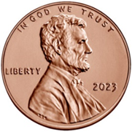Penny: ________________________________

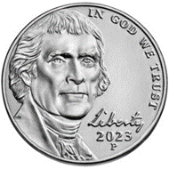Nickel: ________________________________

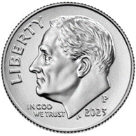Dime: ________________________________

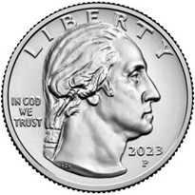Quarter: ________________________________

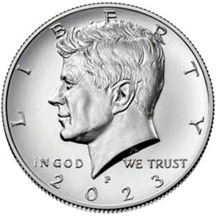Half-Dollar: ________________________________

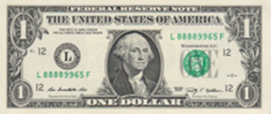Dollar Bill: ________________________________

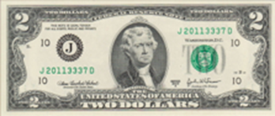$2 Bill: ________________________________

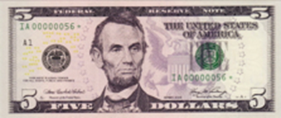$5 Bill: ________________________________

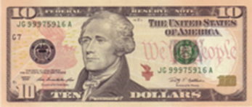$10 Bill: ________________________________

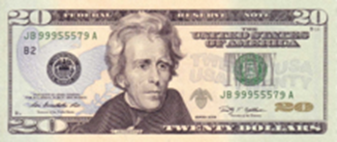$20 Bill: ________________________________

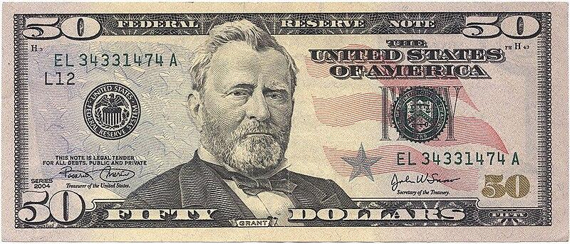$50 Bill: ________________________________

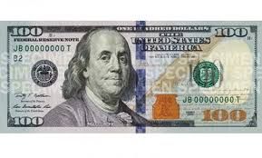$100 Bill: ________________________________